**Confirmations Manager Database Script Creation**

You can generate all scripts of Confirmations Database or other using the next PowerShell program.

This program performs the necessary actions to script all objects on the database.

Script Name: CREATE_SCRIPTS_BASELINE.ps1

**How to Use:**

On Windows Operating System go to Start 🡪 All Programs 🡪 Accessories 🡪 Powershell

Open the PowerShell application then move to the folder files where you have the script files and type the script name and hit Enter then the script request you some parameters require to get connection with the Database that you want work.

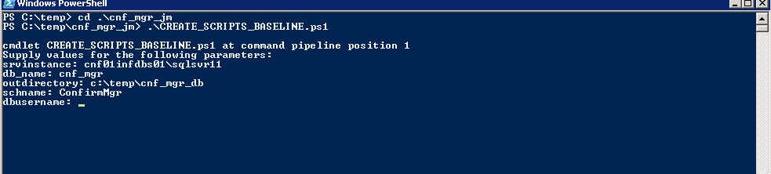

The script program requests some parameter to get connection with the Database then it performs the script generation process.

The parameters are:

**$srvinstance**: Server Instance Name.

For example: CNF01INSDBS01\SQLSVR11

**$db_name**: Refer to the Database names.

**$outdirectory**: Path folder where the scrips will be saved.

For Example: c:\temp\schema.

**$schname**: Refer to the Database Schema that your make a script

Example: cnf_mgr

**$dbusername**: Refer to the user name with sysadmin rights on the Database

**$dbuspassw**: Refer to the user password.



After you provide the Database name, schema, credentials and output directory the script starts to perform the actions to generate the DB scripts.

When the scripts process is done, you will be able to create new clean Database using the SQL scripts set

**Output:**

